Module 2.
Introducing Docker - CD

Technical requirements

- At least 4 gigabytes (GB) of random-access memory (RAM)
- macOS 10.15+, Windows 10/11 Pro 64-bit, Ubuntu 20.04+, or other Linux operating systems

What is Docker?
Docker is an open source project designed to help with application deployment using software containers. This approach means running applications together with the complete environment (files, code libraries, tools, and so on). Therefore, Docker—similar to virtualization—allows an application to be packaged into an image that can be run everywhere.

Containerization versus virtualization
Without Docker, isolation and other benefits can be achieved with the use of hardware virtualization, often called virtual machines (VMs). The most popular solutions are VirtualBox, VMware, and parallels. A VM emulates a computer architecture and provides the functionality of a physical computer. We can achieve complete isolation of applications if each of them is delivered and run as a separate VM image.

The following diagram presents the concept of virtualization:

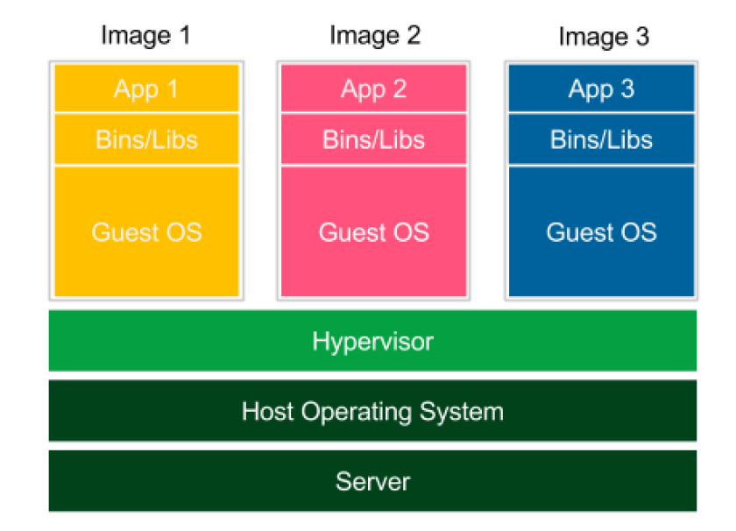

Figure 1 – Virtualization

Each application is launched as a separate image with all dependencies and a guest operating system. Images are run by the hypervisor, which emulates the physical computer architecture.

- Low performance: The VM emulates the whole computer architecture to run the guest operating system, so there is a significant overhead associated with executing each operation.

- High resource consumption: Emulation requires a lot of resources and has to be done separately for each application. This is why, on a standard desktop machine, only a few applications can be run simultaneously.

- Large image size: Each application is delivered with a full operating system, so deployment on a server implies sending and storing a large amount of data.

The concept of containerization presents a different solution, as we can see here:

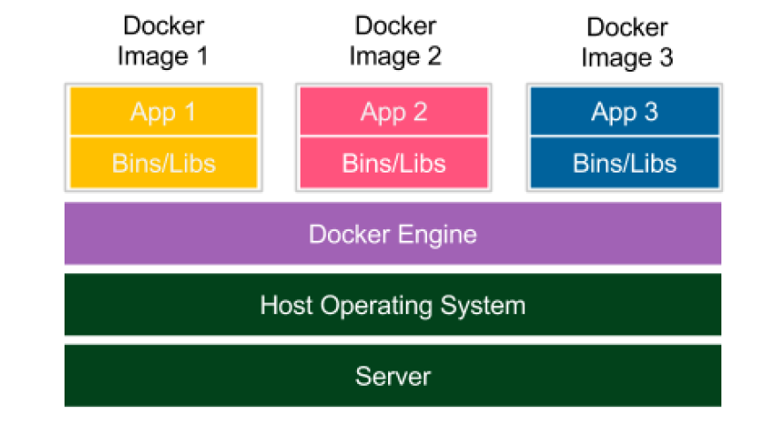

Figure 2 – Containerization

Each application is delivered together with its dependencies, but without the operating system. Applications interface directly with the host operating system, so there is no additional layer of the guest operating system. This results in better performance and no wasted resources. Moreover, shipped Docker images are significantly smaller.

Notice that, in the case of containerization, isolation happens at the level of the host operating system's processes. This doesn't mean, however, that the containers share their dependencies. Each of them has its own libraries in the right version, and if any of them is updated, it has no impact on the others. To achieve this, Docker Engine creates a set of Linux namespaces and control groups for the container. This is why Docker security is based on Linux kernel process isolation.

The need for Docker
Docker containerization solves a number of problems seen in traditional software delivery.

Environment
Installing and running software is complex. You need to make decisions about the operating system, resources, libraries, services, permissions, other software, and everything your application depends on. Then, you need to know how to install it. What's more, there may be some conflicting dependencies. What do you do then? What if your software needs an upgrade of a library, but the other resources do not?

Isolation
Keep the workspace tidy. One application can change the behavior of another one. Imagine what could happen. Applications share one filesystem, so if application A writes something to the wrong directory, application B reads the incorrect data. They share resources, so if there is a memory leak in application A, it can freeze not only itself but also application B. They share network interfaces, so if applications A and B both use port 8080, one of them will crash. Isolation concerns the security aspects, too. Running a buggy application or malicious software can cause damage to other applications. This is why it is a much safer approach to keep each application inside a separate sandbox, which limits the scope of possible damage to the application itself.

Organizing applications
Servers often end up looking messy, with a ton of running applications nobody knows anything about. How will you check which applications are running on the server and which dependencies each of them is using? They could depend on libraries, other applications, or tools. Without the exhaustive documentation, all we can do is look at the running processes and start guessing. Docker keeps things organized by having each application as a separate container that can be listed, searched, and monitored.

Portability
Write once, run anywhere, said the slogan while advertising the earliest versions of Java. Indeed, Java addresses the portability issue quite well. However, I can still think of a few cases where it fails; for example, the incompatible native dependencies or the older version of the Java Runtime. Moreover, not all software is written in Java.
Docker moves the concept of portability one level higher; if the Docker version is compatible, the shipped software works correctly, regardless of the programming language, operating system, or environment configuration. Docker, then, can be expressed by the following slogan: Ship the entire environment instead of just code.

Installing Docker

Prerequisites for Docker

• macOS:
macOS 10.15 or newer
At least 4 GB of RAM
No VirtualBox prior to version 4.3.30 installed

• Windows:
64-bit Windows 10/11
The Hyper-V package enabled
At least 4 GB of RAM

• Linux:
64-bit architecture
Linux kernel 3.10 or later

Running Docker hello-world

docker run hello-world

Let's examine what happened under the hood, as follows:

1. You ran the Docker client with the run command.
2. The Docker client contacted the Docker daemon and asked to create a container from the image called hello-world .
3. The Docker daemon checked whether it contained the hello-world image locally and, since it didn't, requested the hello-world image from the remote Docker Hub registry.
4. The Docker Hub registry contained the hello-world image, so it was pulled into the Docker daemon.
5. The Docker daemon created a new container from the hello-world image that started the executable producing the output.
6. The Docker daemon streamed this output to the Docker client.
7. The Docker client sent it to your Terminal.

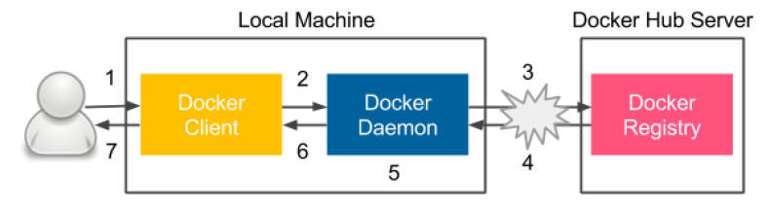

Figure 3 – Steps of the docker run command execution

Docker components

Docker client and server

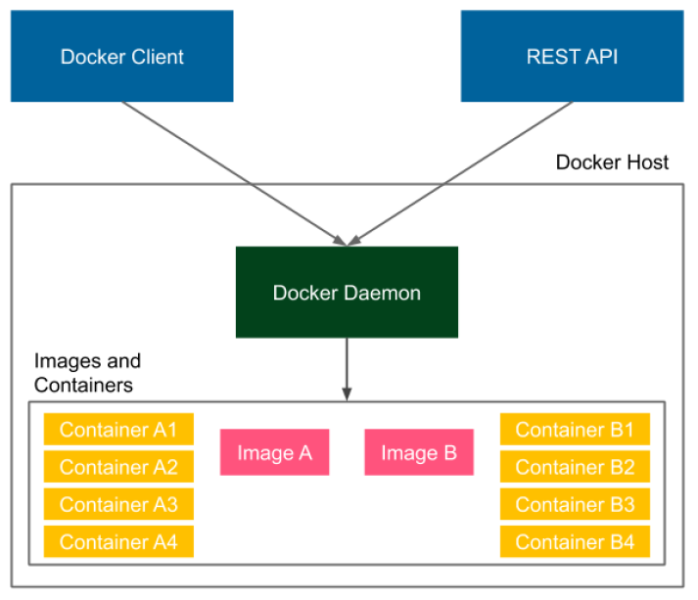

Figure 4 – Docker client-server architecture

Docker Engine consists of the following three components:

• A Docker daemon (server) running in the background
• A Docker Client running as a command tool
• A Docker REpresentational State Transfer (REST) application programming interface (API)

Installing Docker means installing all the components so that the Docker daemon runs on our computer all the time as a service.

Tip
To run the Docker container on a remote machine, you can use the -H option: docker -H <server_ip>:2375 run hello-
world .

Docker images and containers
An image is a stateless building block in the Docker world. You can think of an image as a collection of all the files necessary to run your application, together with the recipe on how to run it. An image is stateless, so you can send it over the network, store it in the registry, name it, version it, and save it as a file. Images are layered, which means that you can build an image on top of another image.

A container is a running instance of an image. We can create many containers from the same image if we want to have many instances of the same application. Since containers are stateful, this means we can interact with them and make changes to their states.

Let's look at the following example of a container and image layered structure:

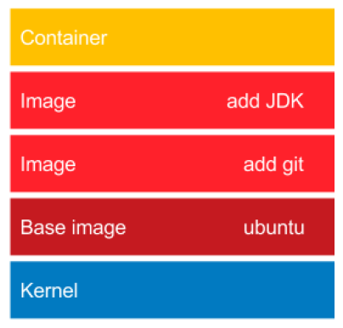

Figure 5 – Layered structure of Docker images

In our example, the ubuntu base image provides all the capabilities of the Ubuntu operating system. The add git image adds the Git toolkit. Then, there is an image that adds the Java Development Kit (JDK) environment. Finally, on the top, there is a container created from the add JDK image. Such a container is able, for example, to download a Java project from the GitHub repository and compile it to a Java ARchive (JAR) file. As a result, we can use this container to compile and run Java projects without installing any tools on our operating system.

It is important to note that layering is a very smart mechanism to save bandwidth and storage. Imagine that we have the following application that is also based on Ubuntu:

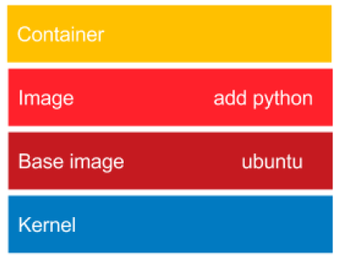

Figure 6 – Reusing layers of Docker images

This time, we files will use the Python interpreter. While installing the add python image, the Docker daemon will note that the ubuntu image is already installed, and what it needs to do is only to add the Python layer, which is very small.

Docker applications
A lot of applications are provided in the form of Docker images that can be downloaded from the internet.

Building Docker images
You can build Docker images using two different methods: the docker commit command and a Dockerfile automated build.

Dockerfile
Creating each Docker image manually with the commit command could be laborious, especially in the case of build automation and the CD process. Luckily, there is a built-in language to specify all the instructions that should be executed to build a Docker image.

• FROM defines an image on top of which the new image will be built
• RUN specifies the commands to run inside the container.

The other widely used instructions are detailed as follows:.

• COPY/ADD copies a file or a directory into the filesystem of the image.
• ENTRYPOINT defines which application should be run in the executable container.

Docker container states
All of the states and the transitions between them are presented in the following diagram:

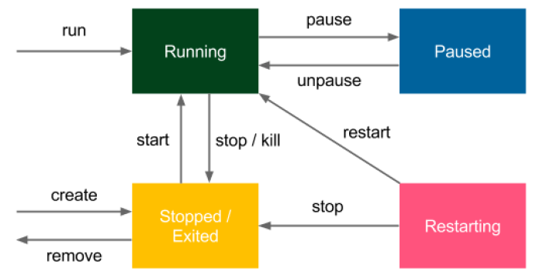

Figure 7 – Docker container states

Information
We've always used the docker run command to create and start a
container. However, it's possible to just create a container without starting it
(with docker create ).

Docker networking
Most applications these days do not run in isolation; they need to communicate with other systems over the network. If we want to run a website, web service, database, or cache server inside a Docker container, we need to first understand how to run a service and expose its port to other applications.

Information
Docker also allows us to publish to the specific host network interface with -p <ip>:<host_port>:<container_port>.

Container networks

• bridge (default): Network through the default Docker bridge
• none : No network
• container : Network joined with the other (specified) container
• host : Host's network stack
• NETWORK : User-created network (using the docker network create command)

Using Docker volumes
Imagine that you would like to run a database as a container. You can start such a container and enter data. Where is it stored? What happens when you stop the container or remove it? You can start a new one, but the database will be empty again. Unless it's your testing environment, you'd expect to have your data persisted permanently.
A Docker volume is the Docker host's directory mounted inside the container. It allows the container to write to the host's filesystem as if it were writing to its own.

Naming containers
There are two good reasons to name a container: convenience and the possibility of automation. Let's look at why, as follows:

• Convenience: It's simpler to make any operations on a container when addressing it by name than by checking the hashes or the autogenerated name.
• Automation: Sometimes, we would like to depend on the specific naming of a container.

Tagging images
Images can be tagged.

docker build -t hello_world_python .

The -t flag describes the tag of the image.

The image can have multiple tags, and they should follow this naming convention:

<registry_address>/<image_name>:<version>

A tag consists of the following parts:

• registry_address : IP and port of the registry or the alias name
• image_name : Name of the image that is built—for example, ubuntu
• version : A version of the image in any form—for example, 20.04 , 20170310

If an image is kept on the official Docker Hub registry, we can skip the registry address. This is why we've run the tomcat image without any prefix. The last version is always tagged as the latest and it can also be skipped, so we've run the tomcat image without any suffix.

Docker commands overview

All Docker commands can be found by executing the following help command:

docker help

Usage: docker [OPTIONS] COMMAND

A self-sufficient runtime for containers

Options:
--config string Location of client config files (default "/root/.docker")
-c, --context string Name of the context to use to connect to the daemon (overrides DOCKER_HOST env
var and default context set with "docker context use")
-D, --debug Enable debug mode
-H, --host list Daemon socket(s) to connect to
-l, --log-level string Set the logging level ("debug"|"info"|"warn"|"error"|"fatal") (default "info")
--tls Use TLS; implied by --tlsverify
--tlscacert string Trust certs signed only by this CA (default "/root/.docker/ca.pem")
--tlscert string Path to TLS certificate file (default "/root/.docker/cert.pem")
--tlskey string Path to TLS key file (default "/root/.docker/key.pem")
--tlsverify Use TLS and verify the remote
-v, --version Print version information and quit
..

To see all the options of any particular Docker command, we can use docker help <command> , as in the following example:

docker help run

Usage: docker run [OPTIONS] IMAGE [COMMAND] [ARG...]

Run a command in a new container

Options:
--add-host list Add a custom host-to-IP mapping (host:ip)
-a, --attach list Attach to STDIN, STDOUT or STDERR
--blkio-weight uint16 Block IO (relative weight), between 10 and 1000, or 0 to disable
(default 0)
--blkio-weight-device list Block IO weight (relative device weight) (default [])
--cap-add list Add Linux capabilities
--cap-drop list Drop Linux capabilities
--cgroup-parent string Optional parent cgroup for the container
--cgroupns string Cgroup namespace to use (host|private)
'host': Run the container in the Docker host's cgroup namespace
'private': Run the container in its own private cgroup namespace
'': Use the cgroup namespace as configured by the
default-cgroupns-mode option on the daemon (default)
..

